IIR Filters using DSP Processor
11.1 Design and Implementation of an IIR Low-Pass Filter using DSP Processor
Program (MATLAB Code)
clc;
clear;
close all;

%% Sampling Parameters
Fs = 8000;
t = 0:1/Fs:0.02;

%% Input Signal
x = sin(2*pi*500*t) + 0.4*sin(2*pi*2500*t);

%% Butterworth IIR Low-Pass Filter
[b,a] = butter(2,1000/(Fs/2),'low');

%% Filter Output
y = filter(b,a,x);
%% Display Only IIR Filter Output
figure('Name','IIR Filter','NumberTitle','off');
plot(y,'b','LineWidth',2);
title('IIR Filter');
xlabel('Time');
ylabel('Points');
grid on;

axis([1 length(y) -1.5 1.5]);

Output
Fig 1
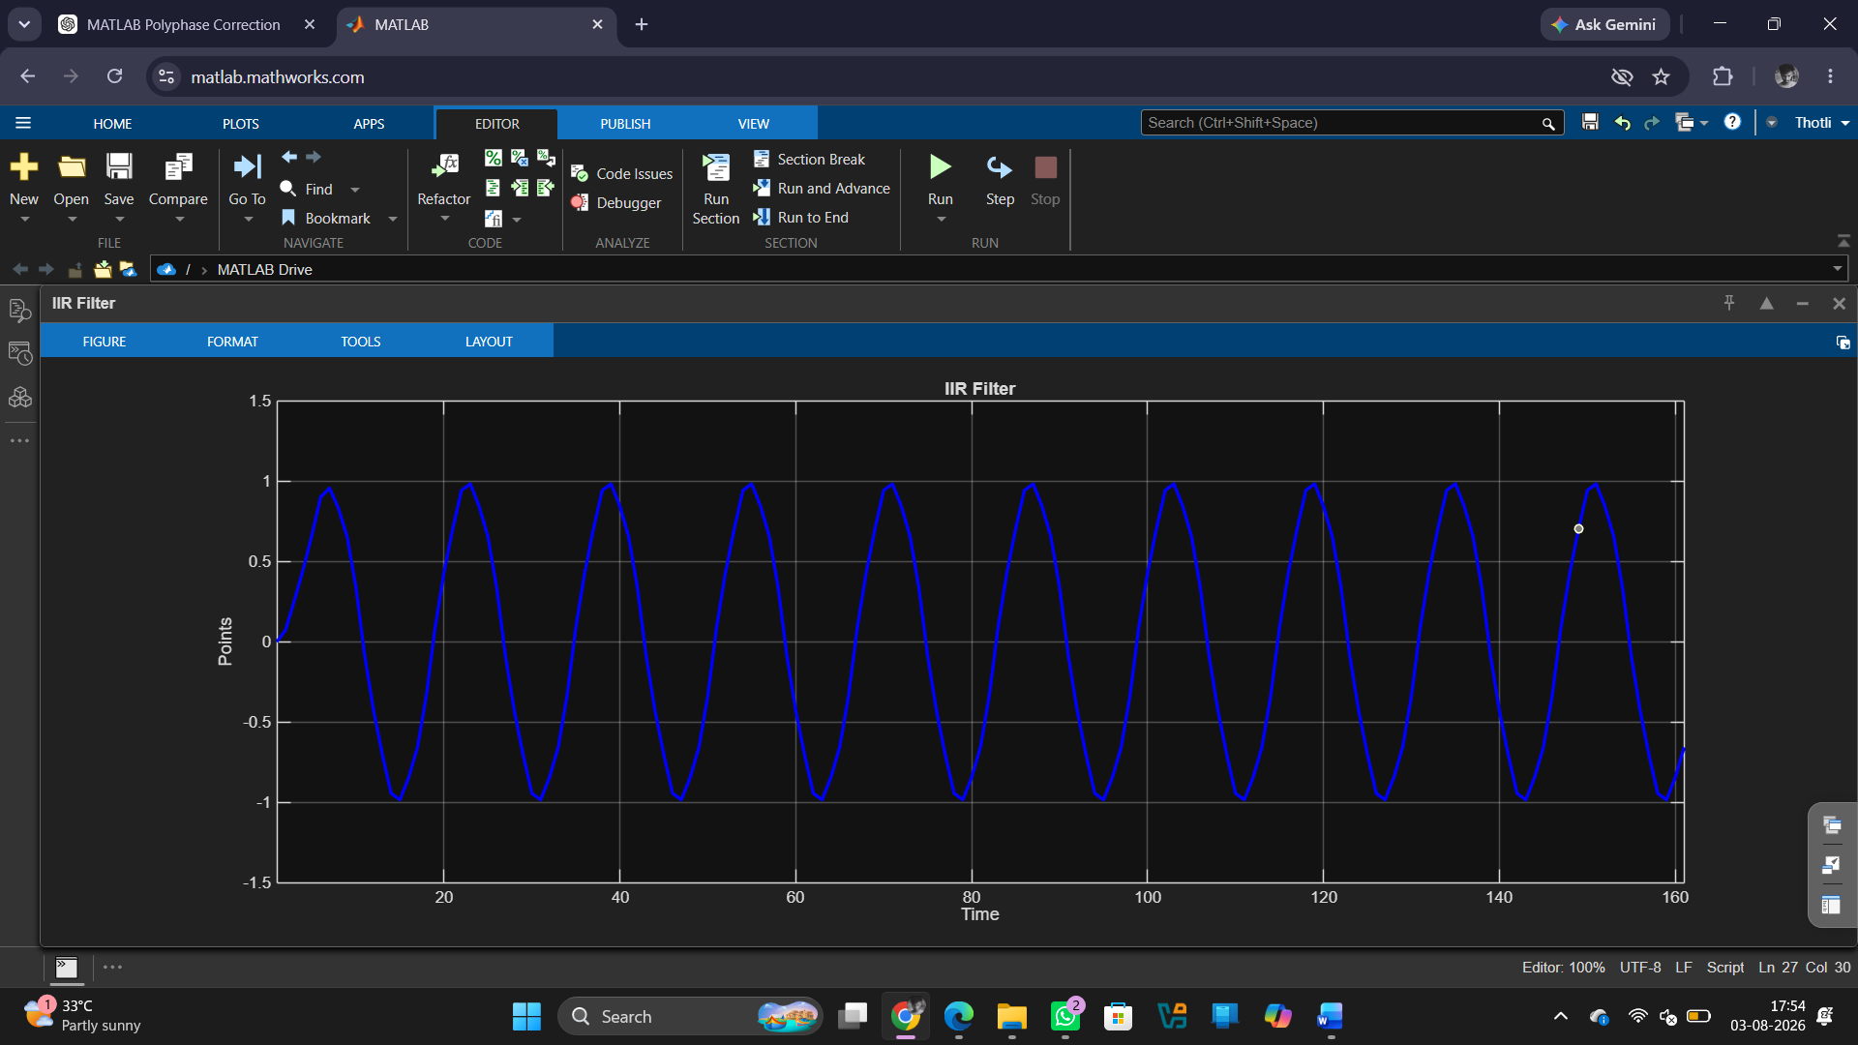

Result
1. The IIR Low-Pass Filter was successfully designed according to the given specifications. 2. The designed filter was implemented on the TMS320C5416 DSP Starter Kit.
3. The input signal was processed through the IIR Low-Pass Filter, and the filtered output was obtained.
4. The output confirmed that low-frequency components were passed while high-frequency components were attenuated, verifying the correct operation of the filter.

